**Using Word embeddings**

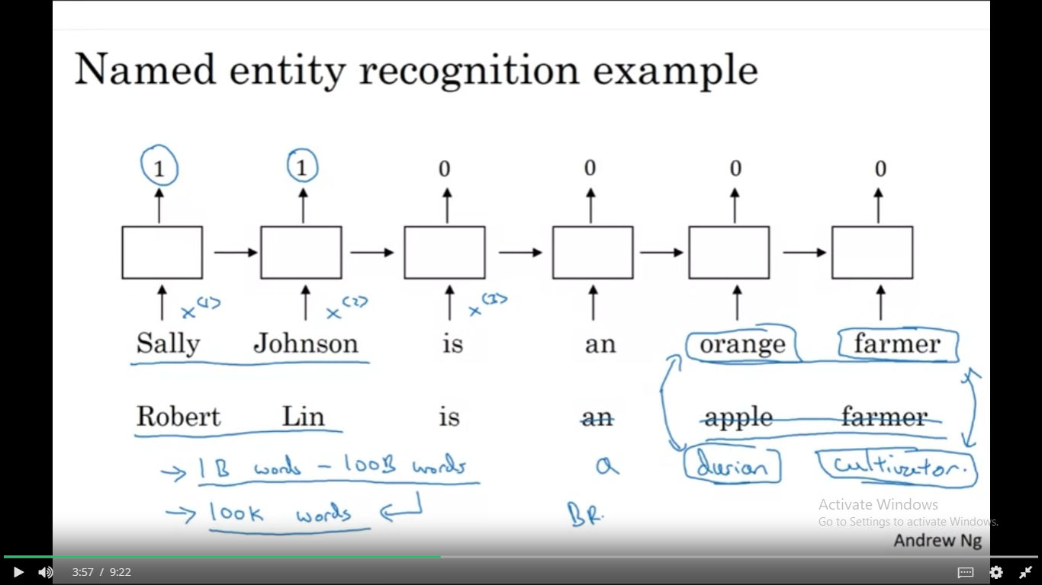

Word embeddings are useful in NLP task such as

* Name entity recognition
* text summarization
* coreference resolution
* parsing

Less useful for

* Language modelling
* Machine translation

